Brief Resume 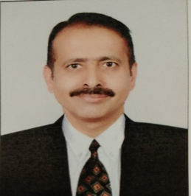
Name | Dr. Sandeep Chopra
Designation | Professor
Professional Experience | 22 Years
Educational Qualification  Institute | MSc. & Ph.D (Vegetable Science)  Punjab Agricultural University, Ludhiana.
Awards | - Awarded Appreciation Certificate for conducting technical and poster session in International Conference-2016 and 2022 by Indian Ecological Society.  - Awarded Excellence Research-Teaching Award for the year-2017 by Indian Society of Genetics, Biotechnology Research & Development, Agra, India.
Area of specialization | Vegetable Production
Students Guided as Major Advisor | 09 ( MSc.) & 01 (Ph.D)
Externally funded Projects handled as P.I | - Technology Refinement and Dissemination of ginger & turmeric in Jammu region (HTMM) : 2011-14  - Technology Refinement and Dissemination of ginger & turmeric in Jammu region (MIDH) : 2014-17  - Coordinator of HADP Project “ Promotiom of Vegetables/Exotic Vegetables under open and protected structures”.
Varietal Development & Adhoc Recommendations | - Associated Production Scientist in the development of three vegetable crop varieties i.e Okra, Cherry Tomato and Broad bean.  - Pre-emergence application of oxadiargyl@ 90g/ha, followed by Post –emergence application of quizalofop-ethyl @ 50g/ha (applied at 2-3 leaf stages of weeds) can effectively control weeds in garlic. (Recommended in Package of Practices of Vegetables, SKUAST-J- 2020)
Institutional Assignments | - Member of technical support team constituted for constant monitoring of high –end technologies.  - Nominated member of departmental academic (DAIP) integrity panel for the division of Agronomy (Faculty of Agriculture).  - Member Student Work Book development team for Job Role (Solanaceous Crop Cultivator, Class 9th & 10th and Tuber crop Cultivator, Class 11th & 12th) prepared by PSS Central Institute of Vocational Education (A constituent unit of NCERT, under MHRD, GOI).
Total no. of publications (Referred journals) | 31
No. of Books & Manuals | 05

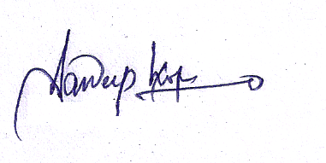
(Sandeep Chopra)

